Are you 65 and over?

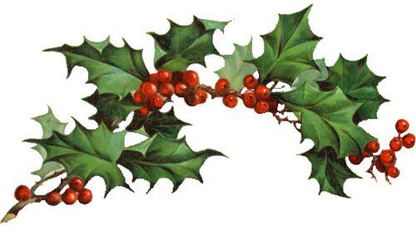
Please come to our Winter Lunch on Friday the 13th December
From 1pm to 2pm
At The Whitehorse Practice.
